GSC-15 Guide

I. Meetings

1. Registration
  - Time: 08:00-09:00;
  - Date: 29 August (Sun) (14:00-18:00)- 30 August (Mon) (08:00-09:00);
  - Place: lobby on the 1st floor of Building 7;

2. HoD Management Meeting
  - Time: 09:00-10:00;
  - Date: 30 August (Mon);
  - Place: No.5 meeting room on the 1st floor of Building 8;
  - Participants: HoDs, Chairmen and one additional representative appointed by each PSO;

3. Opening/Plenary Meeting
  - Time: 09:00-17:30;
  - Date: 30 August (Mon) (10:00 start) – 31 August (Tue) (9:00 start);
  - Place: Meeting Room 1+2 on the 2nd floor of Building 7;
  - Participants: all delegates of GSC-15;

4. ADMIN WG Meeting
  - Time: 18:30-20:00;
  - Date: 31 August (Tue);
  - Place: No.1 meeting room on the 1st floor of Building 8;
  - Participants: all delegates of ADMIN WG;

5. GTSC-8
  - Time: 09:00-12:30;
  - Date: 1 September (Wed);
  - Place: No.5 meeting room on the 1st floor of Building 8;
  - Participants: all delegates of GTSC-8;

6. GRSC-8
  - Time: 09:00-12:30;
  - Date: 1 September (Wed);
  - Place: Meeting Room 1+2 on the 2nd floor of Building 7;
  - Participants: all delegates of GRSC-8;

7. IPR WG Meeting
  - Time: 14:00-17:00;
  - Date: 1 September (Wed);
  - Place: No.1 meeting room on the 1st floor of Building 8;
  - Participants: all delegates of IPR WG;

8. Closing Plenary Meeting
  - Time: 09:00-12:00;
  - Date: 2 September (Thu);
  - Place: Meeting Room 1+2 on the 2nd floor of Building 7;
  - Participants: all delegates of GSC-15;

9. WLAN in meeting room
  - SSID: GSC-15
  - IP Configuration: Automatic
  - DNS: Automatic
  - Technical Support: Mr. Jiang Fu

10. Documents Server (FTP)
  - Upload: ftp://172.16.0.10:2121
  - Download: ftp://172.16.0.10
  - Website: http://gsc15.ccsa.org.cn/

II. Activities
1. Group Photo
  - Time: 12:00-12:10;
  - Date: 30 August (Mon);
  - Place: in front of Building 8;
  - Participants: all delegates of GSC-15; The HoDs and Chairs are recommended to sit on the first row.

2. Lunch
  - Time: 12:30-14:00;
  - Date: 30 August (Mon) – 2 September (Wed);
  - Place: Yashi Restaurant on the first floor of Building 1;
  - Participants: all delegates of GSC-15 and the accompanying persons by meal coupon;

3. HoD-only Lunch
  - Time: 12:30-14:00;
  - Date: 1 September (Wed);
  - Place: Jinsongtai Restaurant on the first floor of Building 1;
  - Participants: HoDs;
  - Dressing: Formal;

4. Welcome Reception
  - Time: 18:00-20:00;
  - Date: 30 August (Mon);
  - Place: Multifunction Hall in Building 1;
  - Activities: 30 minutes’ cocktail party followed by the dinner
  - Participants: all delegates of GSC-15 and the accompanying persons;
  - Dressing: Formal;

5. Social Event
  - Time: 17:30-21:00;
  - Date: 1 September (Wed);
  - Place: The Summer Palace;
  - Activities: Cruise on the Kunming Lake for about 1 hour and have the dinner in The Imperial Tingli Hall Restaurant in the Summer Palace — back to the hotel.
  - Participants: all delegates of GSC-15 and the accompanying persons;
  - Gathering: In front of Building 1. Three buses will be waiting there.
  - Grouping:
— Participants with red ribbon hanging the representative cards are requested to take the bus 1 and boat 1;
— Participants with yellow ribbon hanging the representative cards are requested to take the bus 2 and boat 2;
- Participants with blue ribbon hanging the representative cards are requested to take the bus 3 and boat 3;
  - Dressing: Business casual
  - Tour Guide: 3 English Tour Guides

6. Technical Tour
  - Time: 13:00-20:00;
  - Date: 2 September (Thu);
  - Place: The Mutianyu Great Wall;
  - Activities: Touring on the Mutianyu Great Wall for about 2 hours (by cable car) and have the dinner in Xiaolongpu Restaurant or Meizhoudongpo Restaurant — back to the hotel.
  - Participants: all delegates of GSC-15 and the accompanying persons;
  - Gathering: In front of Building 1. Three buses will be waiting there.
  - Grouping:
— Participants with red ribbon hanging the representative cards are requested to take the bus 1;
— Participants with yellow ribbon hanging the representative cards are requested to take the bus 2;
- Participants with blue ribbon hanging the representative cards are requested to take the bus 3;
  - Dressing: Casual
  - Tour Guide: 3 English Tour Guides

7. Beijing One Day Highlights Tour
  - Time: 08:30-20:00;
  - Date: 31 August (Tue);
  - Place: The Forbidden City, The National Stadium, Hutongs (alley), and Acrobatics Show;
  - Activities: Visit Tian’an Men Square and Forbidden City for about 2.5 hours — Hutongs (alley) — Lunch — the National Stadium — Dinner — Watching Acrobatics Show — back to the hotel.
  - Participants: the accompanying persons;
  - Gathering: In front of Building 1. A Mini bus will be waiting there.
  - Tour Guide: 1 English Tour Guide

III. Secretary:
Mr. Shizhuo Zhao Mr. Xu Qi
Mobile: +86-13671348485 Mobile: +86-13466724696
Email: zhaosz@ccsa.org.cn Email: qixu@ccsa.org.cn

Secretariat Room: No.4 room (VIP) in Building 8

Note: The above mentioned information may be updated and be announced during the meeting if necessary.

IV. Annex

Annex 1: GSC-15 Schedule
Time/Date | Monday  (Aug. 30) | Tuesday  (Aug 31) | Wednesday  (Sep 1) |  | Thursday  (Sep 2)
08:00-09:00 | Registration | Registration | Registration |  | Registration
09:00-10:30 | HoD/Mgt Meeting (09:00-10:00) | Plenary | GRSC | GTSC | Closing Plenary
Opening Address
(10:00-10:30)
10:30-11:00 |  | Coffee | Coffee |  | Coffee
11:00-12:30 |  | Plenary | GRSC | GTSC | Closing Plenary
Plenary
(10:30-12:00)
12:30-14:00 | Lunch | Lunch | Lunch | HoD-only Lunch | Lunch (12:00-13:00)
14:00-15:30 | Plenary  (13:30 start) | Plenary | IPR WG |  | Technical Tour  (13:00-20:00)
15:30-16:00 | Coffee | Coffee | Coffee
16:00-17:30 | Plenary | Plenary | IPR WG  (-16:00)
18:00-20:00 | Welcome Reception | ADMIN WG  （18:30-20:00） | Social Event  (evening)

Annex 2: Layout of the Beijing Friendship Hotel
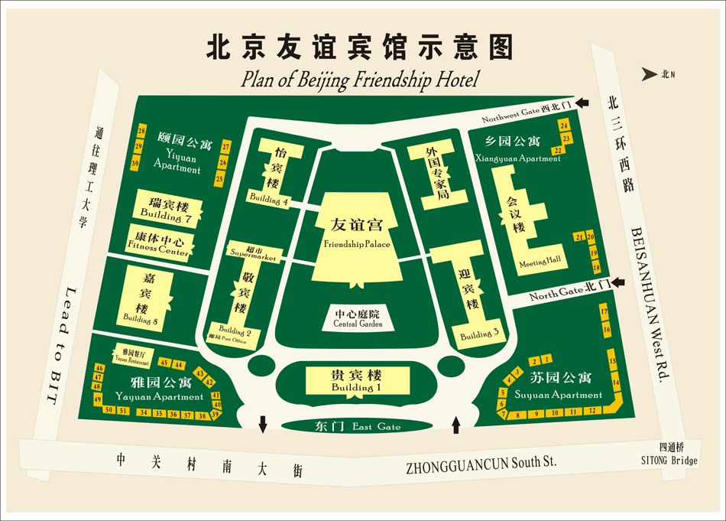
- Registration
- Opening/Plenary Meeting;
- GRSC-8;
- Closing Plenary Meeting.
1. HoD Management Meeting;
2. ADMIN WG Meeting;
3. GTSC-8;
4. IPR WG Meeting;
5. Group Photo (in front of Building 8).
- Lunch;
- HoD-only Lunch;
- Welcome Reception;
- Gathering Place for Social Event, Technical Tour, Beijing One Day Highlights Tour (in front of Building 1)
- Accommodation

